**Method of Synthesising a Solution**

Initially a justification of the problem is carefully argued and justified. And then some background research was done by reading articles and previous researches papers that has been done in this field before.

Next, by the aid of a spider diagram, different ideas were created and put forward to find an innovative solution. Hence by carefully examining the limitations and design constraints, the ideal design is put forward.

Finally, with the aid of parametric design calculations on Excel, an optimized solution was found, and a counter flow forced draft cooling tower with shell & tube heat exchanger were designed to tackle the issue.

|  |  |
| --- | --- |
| Related image  Design of a cooling tower  THER307 COURSEWORK ASSIGNMENT | **Abstract**  This project aims to design a forced draft cooling tower and a heat exchanger for an IC engine testing lab to conserve water. By making reasonable assumptions and following the system design specification, an environmental friendly, cost-effective and sustainable cooling tower can be designed.  Arian Bahadori - 10567899  Dead line: 27/11/2019 |

**Introduction**

Cooling towers are widely used to reduce water temperatures. When a hot water is sent into a cooling tower, the cooling tower reduces the water temperature and causes heat rejection into the atmosphere. The make-up water source replenishes the water lost due to evaporation. Then the cooled water is recollected at the bottom of the tower and pumped back into the heat exchanger (Subramanian, 2019)

The heat exchanger is used to enable heat transfer between the engines and the cooling tower fluids to take place. The circulating fluids follow through the heat exchanger, and due to the temperature gradient, heat transfer takes place. The following shows the system designed for this project.

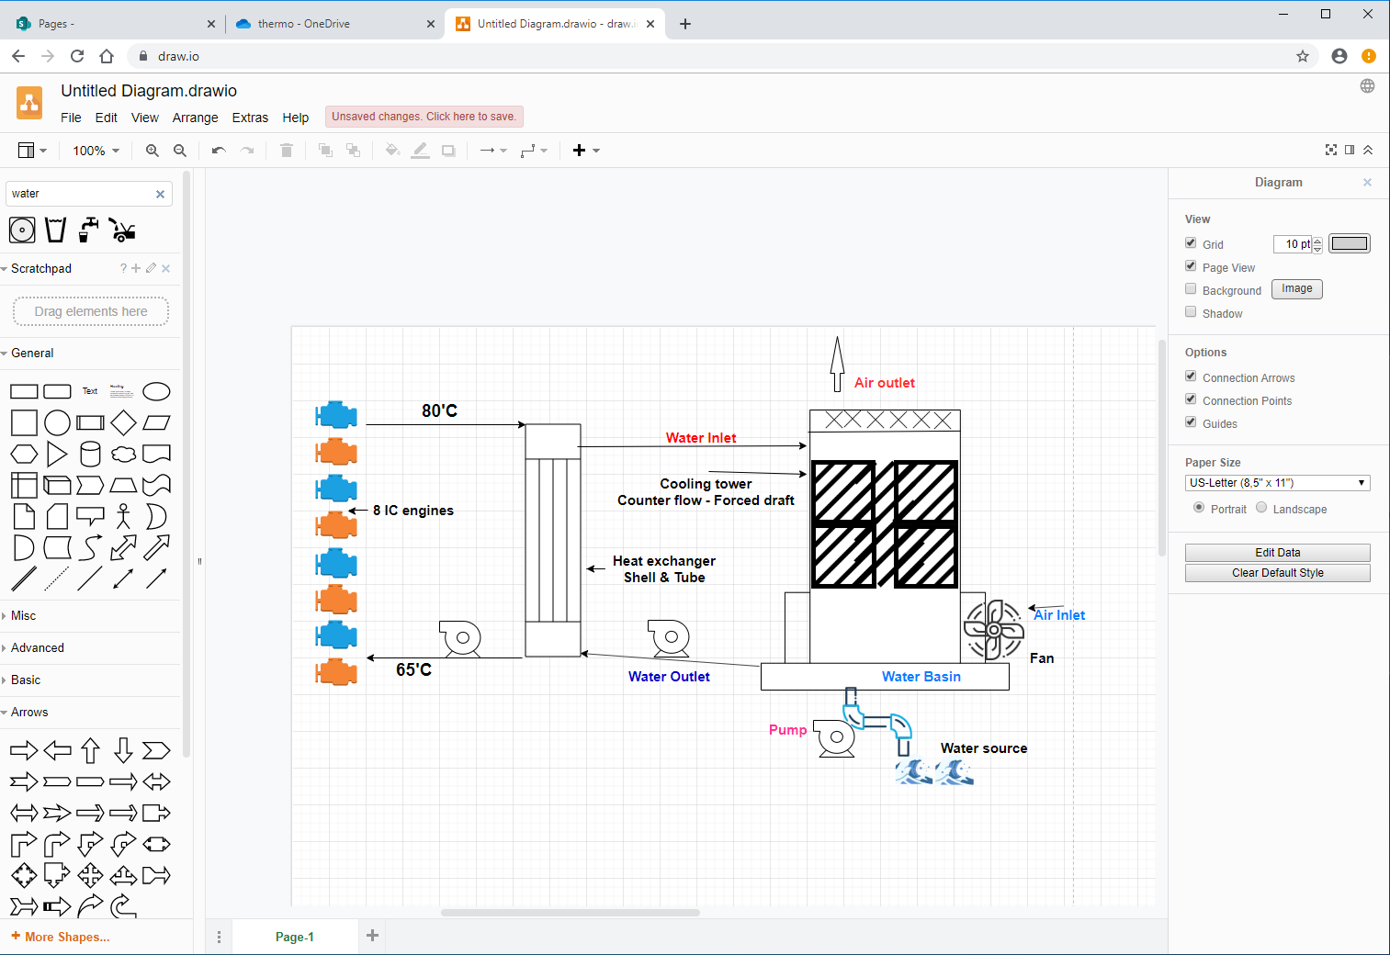

**The design specification**

1. Heat exchanger must return at 65’C
2. System needs to facilitate an output power of 55KW for 6 engines
3. Water as coolant
4. Cooling tower: forced draft
5. 24 ‘C Ambient temperature
6. 65% Atmospheric Relative humidity
7. Fluids in HE have indirect contact

**Nomenclature**

Maximum average heat transfer,

Specific heat of water,

Mass flow rate, s^-1

Change in temperature,

Log Mean Temperature Difference,

Temperature effectiveness

Heat capacity rate ratio

Reynold number

Desnity, kg/m^3

Average flow velocity, ms^-1

Dynamic viscosity, kg/sm

Thermal conductivity, W/mk

A Cross sectional area, m^2

Diameter of tube/shell, m

Prandtl number

Nusselt number

heat transfer coefficient,

Number of tubes

Number of baffles

Volumetric heat transfer coefficient

Enthalpy of air at inlet, kJ/kg

Enthalpy of air at outlet, kJ/kg

Enthalpy of air at the middle of tower

Enthalpy of water at middle of tower

Stevens ratio at inlet

Stevens ratio middle

Stevens ratio outlet

Overall heat transfer coefficient,

**The Heat Exchanger [Shell & tube / Counter Flow / 1 Pass]**

To satisfy the design requirements, a parametric solution was made, which assists the calculation of the design. The heat transferred to the cooling jackets was found. Assuming an adiabatic flow with IC engine thermal efficiency of 30%, the heat transferred to the cooling jacket was obtained:

Max average power output per engine: 55kW  
Thermal efficiency estimated: 30%

The input power =   
Output thermal power: 183.3-55 = 128.3 kW

Since the number of engines operating simultaneously was 6, the total output thermal power is obtained:

Hence, by rearranging the heat transfer formula , the hot water mass flow rate is:

Then by a reasonable assumption, cold-water inlet temperatures estimated to be 303.15°K and 315.15°K for the inlet and outlet respectively. Therefore, the Log mean temperature difference (LMTD) and cold mass flow rate were calculated to be:

Afterwards, by using the correction factor vs temperature effectiveness graph, the corrected LMTD values can be obtained. Therefore, by calculating the P and R value from the temperatures, the correction factor can be determined on the graph. This is because the factor F is dependent on temperature effectiveness P and heat capacity rate ratio R for a given flow arrangement.

The correction factor can be read using the red line in this design. The correction factor of 0.98 is achieved, enabling the corrected LMTD calculation:

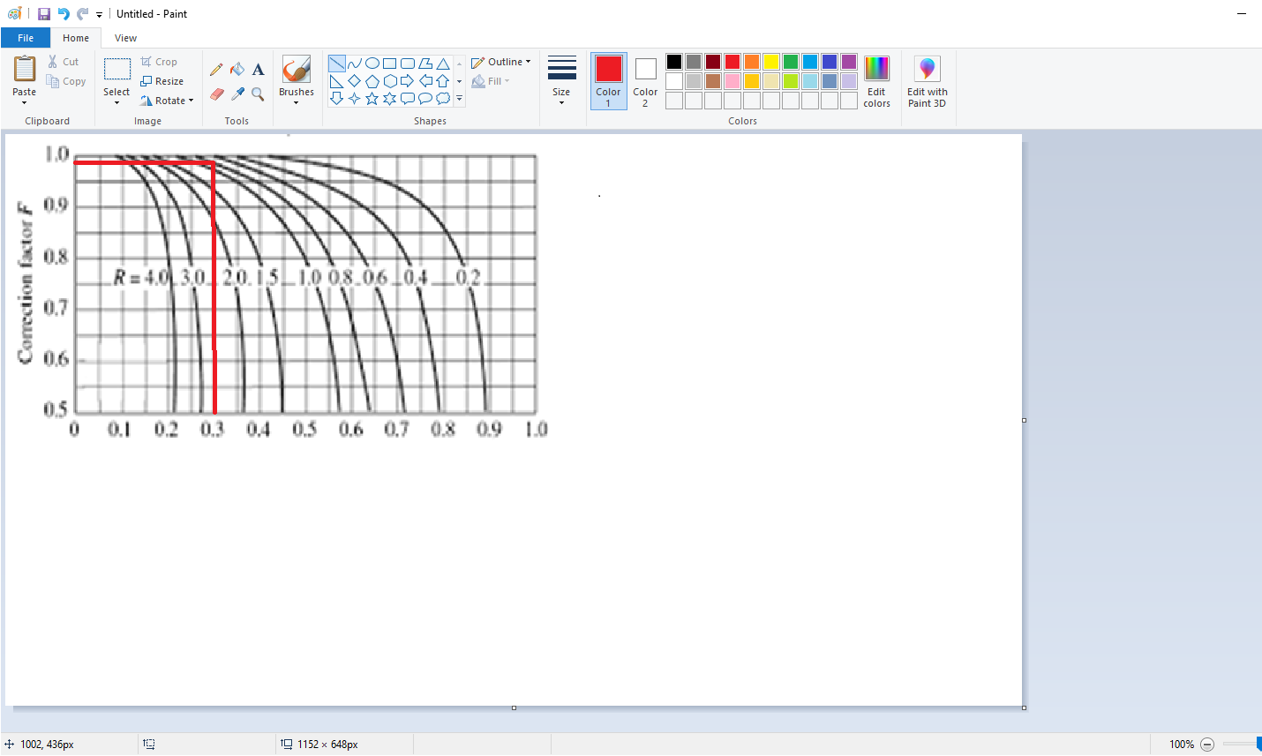

Furthermore, the calculations for the overall convective heat transfer coefficient is required. Therefore, the method used needs Reynold number, Prandtl number, and using these the Nusselt number were calculated, using the assumed hot tube diameter of 0.03m. And the shell diameter then could be calculated from these numbers:

The equation used for Reynolds, Prandtl and Nusselt numbers for pipe flow are:

Since there are 8 rows and 8 columns, a 0.03875m transverse and longitudinal pitch has be assumed, with a diagonal pitch of 0.0433m. Therefore, the overall diameter of the shell is estimated to be 0.4 m.

**Hot flow values**

**Cold flow values**

The heat transfer coefficients (, can be obtained, using the equation

The overall convective heat transfer coefficient calculated. The material’s convective heat transfer of the tube (thickness of 0.001) was considered negligible as it was too small to consider it. thus:

And by using this value, the necessary surface area for the heat transfer within the heat exchanger calculated using this equation:

And finally, the length of the tube can be calculated from the area;

The number of baffles can be gauged via the equation;

The diagram below shows the counter flow shell and tube heat exchanger with one pass. The total number of tubes are 64, in an 8X8 arrangement, shown at the bottom left of the diagram.

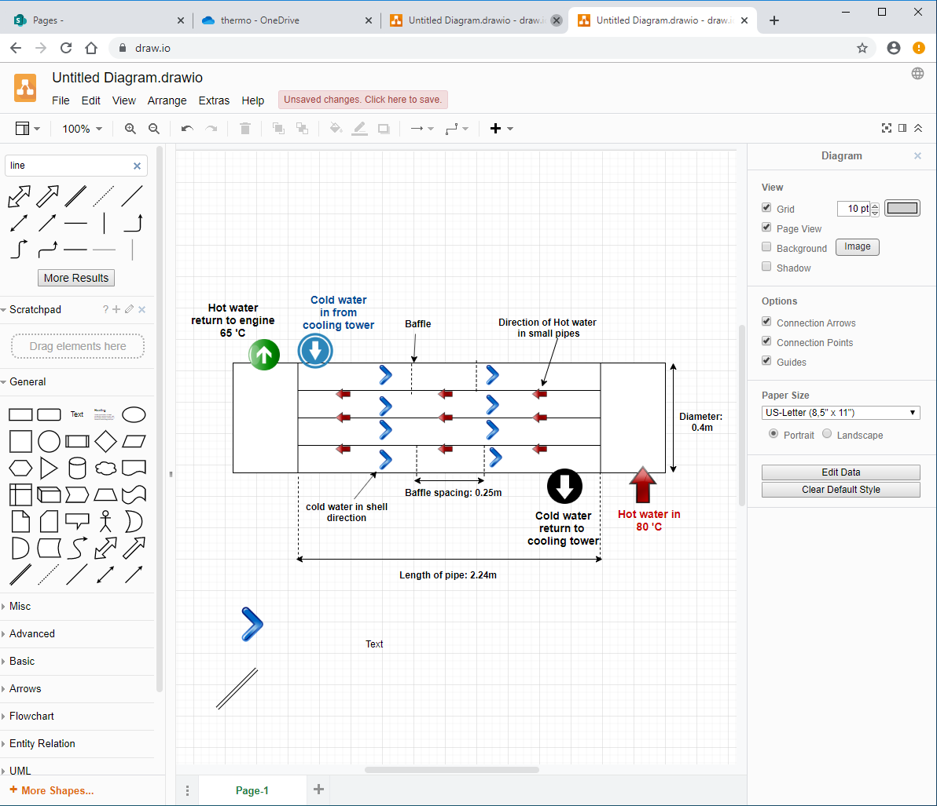

**Cooling Tower**

The conditions for the cooling tower have been set to have an ambient d.b temperature of 24’C and 65% humidity. The assumed outlet temperature of 36 ‘C was made. And using the Psychrometric chart below, the specific enthalpy was determined to be 55.5 kJ/kg, and the wet bulb temperature to be 19.5 ‘C. The rest of the values were found using the thermodynamic steam table.

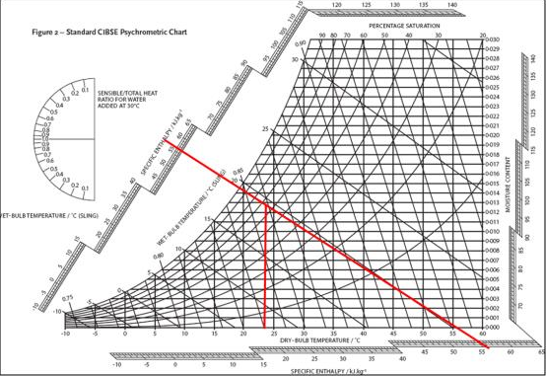

**Cooling Tower Calculations**

Calculations are easy and straight forward. The following values were read of the steam graph directly (Edge, 2019), and in the calculations, the original c, m and n values were used for the packing characteristics since the actual packing used (VFH 20-Vertical offset fill) has “unknown packing characteristics”.

Air moisture content at inlet 0.012 kg/kg  
Air moisture content at outlet 0.041 kg/kg  
Enthalpy of water at inlet 175.8   
Enthalpy of water at outlet 125.7  
Enthalpy of air at inlet 55.5 kJ/kg  
Water isobaric heat capacity 4.178 kJ/kgK

|  |  |
| --- | --- |
| Packing characteristics | |
| c | 2.98 |
| m | 0.2 |
| n | 0.27 |
| C | 2.22 |
| m | 0.8 |
| Packing height | 0.5 m |
| Number of cells | 2 |
| Overall pack height | 1 m |

Air mass flow rate required in tower

The water’s mass flow rate per c.s.a of pack is calculated by using the cold mass flow rate found from the previous calculation in heat exchangers, where:

Furthermore, the determination of the volumetric heat transfer coefficient based on the provided packing characteristics, is found:

Enthalpy of the air at the outlet was then calculated:

With the help of the graph below, a deeper understanding of the values calculated above. This graph shows indicates what range and approach and where some of the ratios that has been calculated come from.

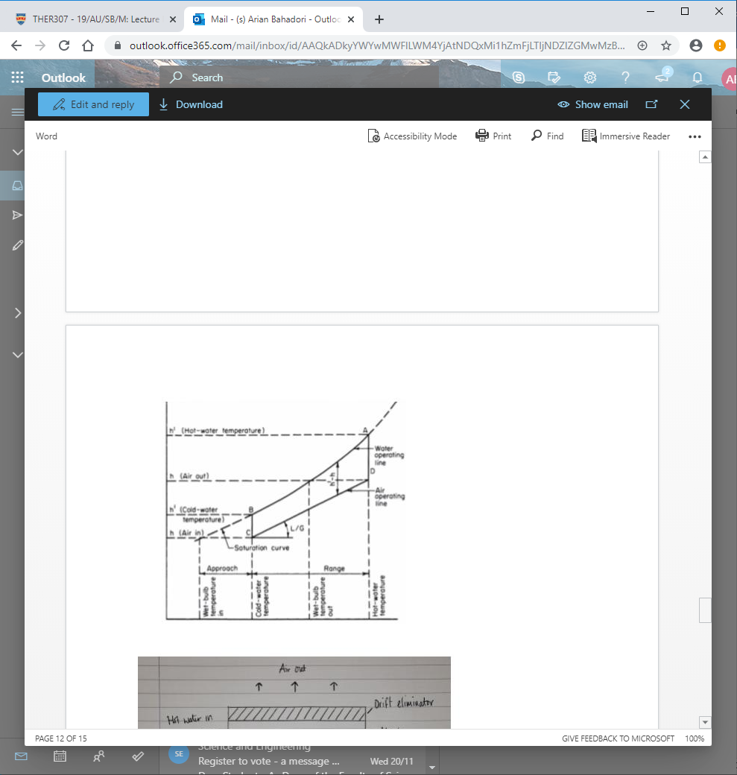

Now With the help of enthalpies of water and air inlets and outlets, enthalpies at the middle of the tower can be determined from the average values:

With these values obtained, a factor from the Steven’s chart is read using the Steven’s ratio:

And, using these values, we plot them on the graph, and see where they intersect.

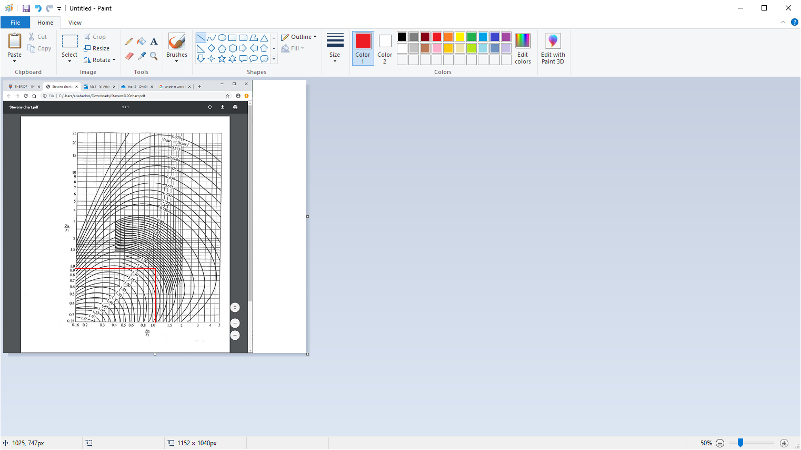

A correction factor, f of 1.00 can be read from the graph. With this value the mean driving force of the tower was calculated:

Now an evaluation of hc that was calculated earlier is made

The initial volumetric heat transfer coefficient calculated was 2.46, and this was very different from 4.25. Hence by changing the area of the cooling tower to 3.3 m^2 from 5 m^2, the hc value changed to 4.66, and it changed to 4.61 from the c.s.a packing characteristic. These numbers are very close, and hence it means that the demand is met, and this satisfies it.

And finally, the cooling tower effectiveness was found using (Rao, 2019):

I believe this value for the given function of the tower is very adequate. We want to build a suitable tower with reasonable costs and having a high CT effectiveness means very large tower is required. The following figure shows the designed cooling tower.

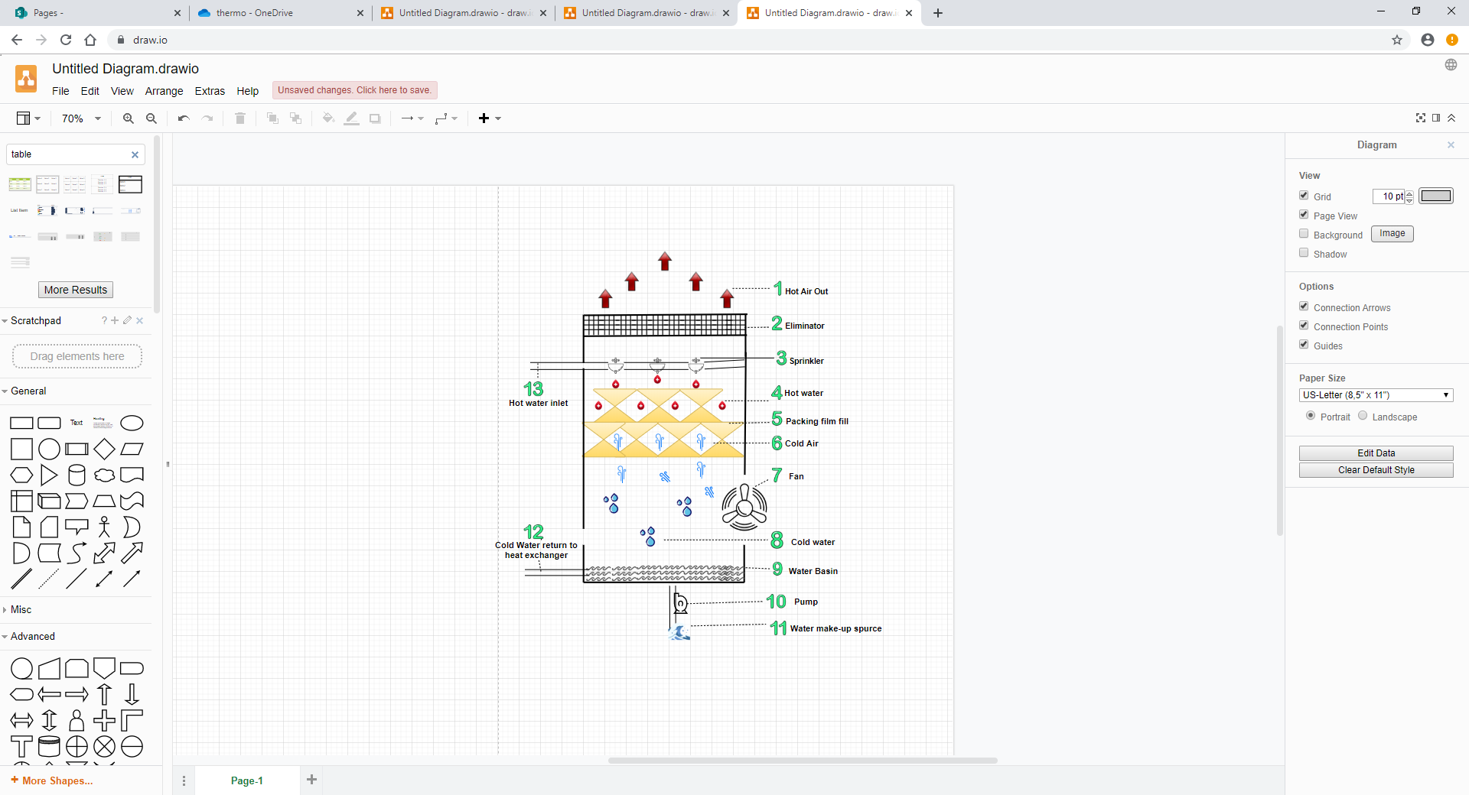

**Fan - GBDF4 Flue Dilution**

Fan is used at the bottom of the cooling tower to provide draft by forcing the air into the cooling tower. The air enters the cooling tower from the air inlet valve as it by passes the fan at the bottom of the tower, (Chiesa, 2019). This enables the counter flow pattern to take place since the air moves vertically upwards. The use of fan is critical for mechanical draft towers. This is because in small cooling towers the natural draft of air isn’t sufficient enough, therefore the fan enhances the temperature gradient by continuously moving the air in.

The fan used in this system is GBDF8 Flue Dilution. This fan enables easy electrical installation. The GBDF8 Flue Dilution fan is usually used for large industrial boilers since it deals with range of temperatures from cold to the maximum temperature allowed of 110 ‘C. This fan can get up to 340 litres per second of air to go through the inlet valve. It has 120X120 cm inlet and outlet valves.  
This fan also provides an internal differential pressure switch for safety which shuts off in emergency.

**Exchanger Fill - VFH 20-Vertical offset fill**

The how water that comes in from the heat exchanger and into the cooling tower is sprayed into the cooling tower via nozzles. This spraying of water is sometimes vertically upwards to give more time for heat transfer to take place. The sprayed water falls on the exchanger fills, which slows the motion of water and on the other hand, optimises the contact area between air and water. The exchanger gill in this system is VFH 20-Vertical offset fill. This fill has high longevity, and effective surface area of 140 m^2/m^3, which is relatively high for its price (Homepage, 2019).

Unfortunately, even with contacting the manufacturer and hours of research spent, the characteristics of this fill is still unknown. Therefore, in the calculations, the original c, m and n values were used. However, a higher effectiveness of the cooling tower is almost guaranteed, based on the characteristics that was discussed in previous paragraph. The Polyvinylchloride material of this filling provides higher heat transfer efficiency because no debris would be built, therefore no water passage blockage would occur (Homepage, 2019).

**Drift eliminator & water base**

Some of the water is evaporated during this process, even though the drift eliminator at the top of the tower eliminates the saturated water droplets from escaping the tower, (Jassim, 2016) the rest is collected at the bottom of the cooling tower in a water basin. This is where the water is kept and the water that was lost due to evaporation is made-up by usually a natural source, such as rivers. Then the water gets pumped into the pipe for its application.

**Pump - GMP PTO Powered Self priming pumps**

The pump is used to induce flow and raise the coolant from a low to higher level. It works by converting rotational energy into a kinetic energy in the moving fluid. The pump used in this case is the GMP PTO Powered Self priming pumps. In this system, the maximum water volumetric flow rate demand is 1106.7 l/m. This pump provides 1200 l/m, which satisfies the needs.

**Build up material of the tower**

The cooling tower is using galvanized steel as a tower build up material, since it has high resistance to corrosion. It also has lower costs than other corrosion resistance materials. Galvanized steel is malleable and can take the desired shape easily. Galvanized steel, which is also known as the hot-dip zinc coated steel is 100% recyclable, which makes it environmentally friendly, (Jassim, 2016).

**Pipe & other considerations**

* An estimated 10 meters of pipe is needed for the fluid flow to and from the tower and the heat exchanger. The material used for the pipes are galvanized plain steel, due to longevity.
* By increasing the height, a longer contact time between water and air takes place, therefore a greater heat transfer would occur. However, this would also increase the costs and occupied space in direct proportion. The total tower height in this design is 3 meters.
* The higher the number of transfer units, the lower the energy loss. Therefore, by achieving an NTU number of 0.8, this system suggests to be a relatively efficient design.

Cost Analysis

**1) Fan**: GBDF8 Flue Dilution Fan   
Material: Stainless Steel Corrosion resistance: Excellent  
Inlet Louvre: 1200x1200 mm Discharge grille size: 1200x1200 mm  
Operation at high temperatures: Yes, Low maintenance: Yes

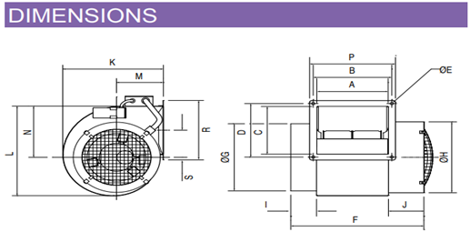(All the dimensions are in mm)

|  |  |  |  |  |  |  |  |  |  |  |  |  |  |  |  |  |
| --- | --- | --- | --- | --- | --- | --- | --- | --- | --- | --- | --- | --- | --- | --- | --- | --- |
| A | B | C | D | E | F | G | H | I | J | K | L | M | N | P | R | S |
| 980 | 1034 | 664 | 355 | 14 | 1784 | 908 | 908 | 400 | 400 | 970 | 980 | 464 | 672 | 984 | 696 | 290 |

Price: £1860.00 (Airflow.com, 2019)

**2) Pump**: GMP PTO Powered Self priming pumps  
Inlet Diameter: 76.2mm Outlet Diameter: 76.2mm  
Max flow: 1200 l/min Max head: 30m  
Maximum water pump requirement:

The selected pump provides 1200 L/min, which makes it ideal.  
3 Pumps needed; 1 from make-up water source to basin, 1 from basin to the heat exchanger and 1 for the heat exchanger to the engines.  
Price for one: £1137.24 (LTD, 2019) Total price: £3411.70

**3) Packing Film**: VHF-20 Vertical Offset Film Fill   
It increased the time taken and the contact area between hot water and cold air in  
Area of the packing: 0.7*0.8: 0.56 Price of 1 packing: £5  
Cross sectional area of the tower: 5.6 Delivery price + VAT added.  
Durable Material: Polyvinylchloride (PVC), Large effective surface: 140 m^2/m^3  
Width*Length*Height = 0.7*0.8*0.5Hence dividing the packing area by total area gives us the number of packings we need: 5.6/0.56= 10  
the height of this packing is 0.5, whereas the total packing area is 1m, which indicates we need 2 cells. Therefore, multiply 10 by number of cells: 20.  
Price (Including VAT + Delivery from China): £120 (alibaba, 2019)

**4) Heat Exchanger**: Shell & Tube (Counter flow)  
Number of tubes: 64 Length of pipes: 2.18m  
Diameter of pipe: 0.03m Material: Stainless steel  
Price: £4500 (alibaba, 2019)  
  
**5) Pipe & Fittings**: Galvanized Plain Pipe   
Estimated length for the medium to flow through the system: 10m Diameter:4”  
Price: £737.5 (LTD, 2019)

**6) Cooling Tower Metal Sheet**: 3mm thick – Galvanized Steel Sheet (LTD, 2019)  
Height, Width, Length: 1.8 * 1.5 * 2.2  
Sheet for Front and back: 1.8*1.5*2=5.4 m^2 Costs: £332.73  
Sheets for the sides: 1.8*2.2*2=7.92 m^2 Costs: £488.24  
Price: £1050.64

The Minimum Costs: £11679.84  
However, based on the predictions, other costs such as eliminators, sprinklers, fittings etc, would also add up, hence the Estimated total costs: £12,000

The **Casing** dimensions & diagram

The following diagram is showing the full casing dimensions such as height, depth and width of the tower, also dimensions of the heat exchanger with the calculated water temperatures are provided.

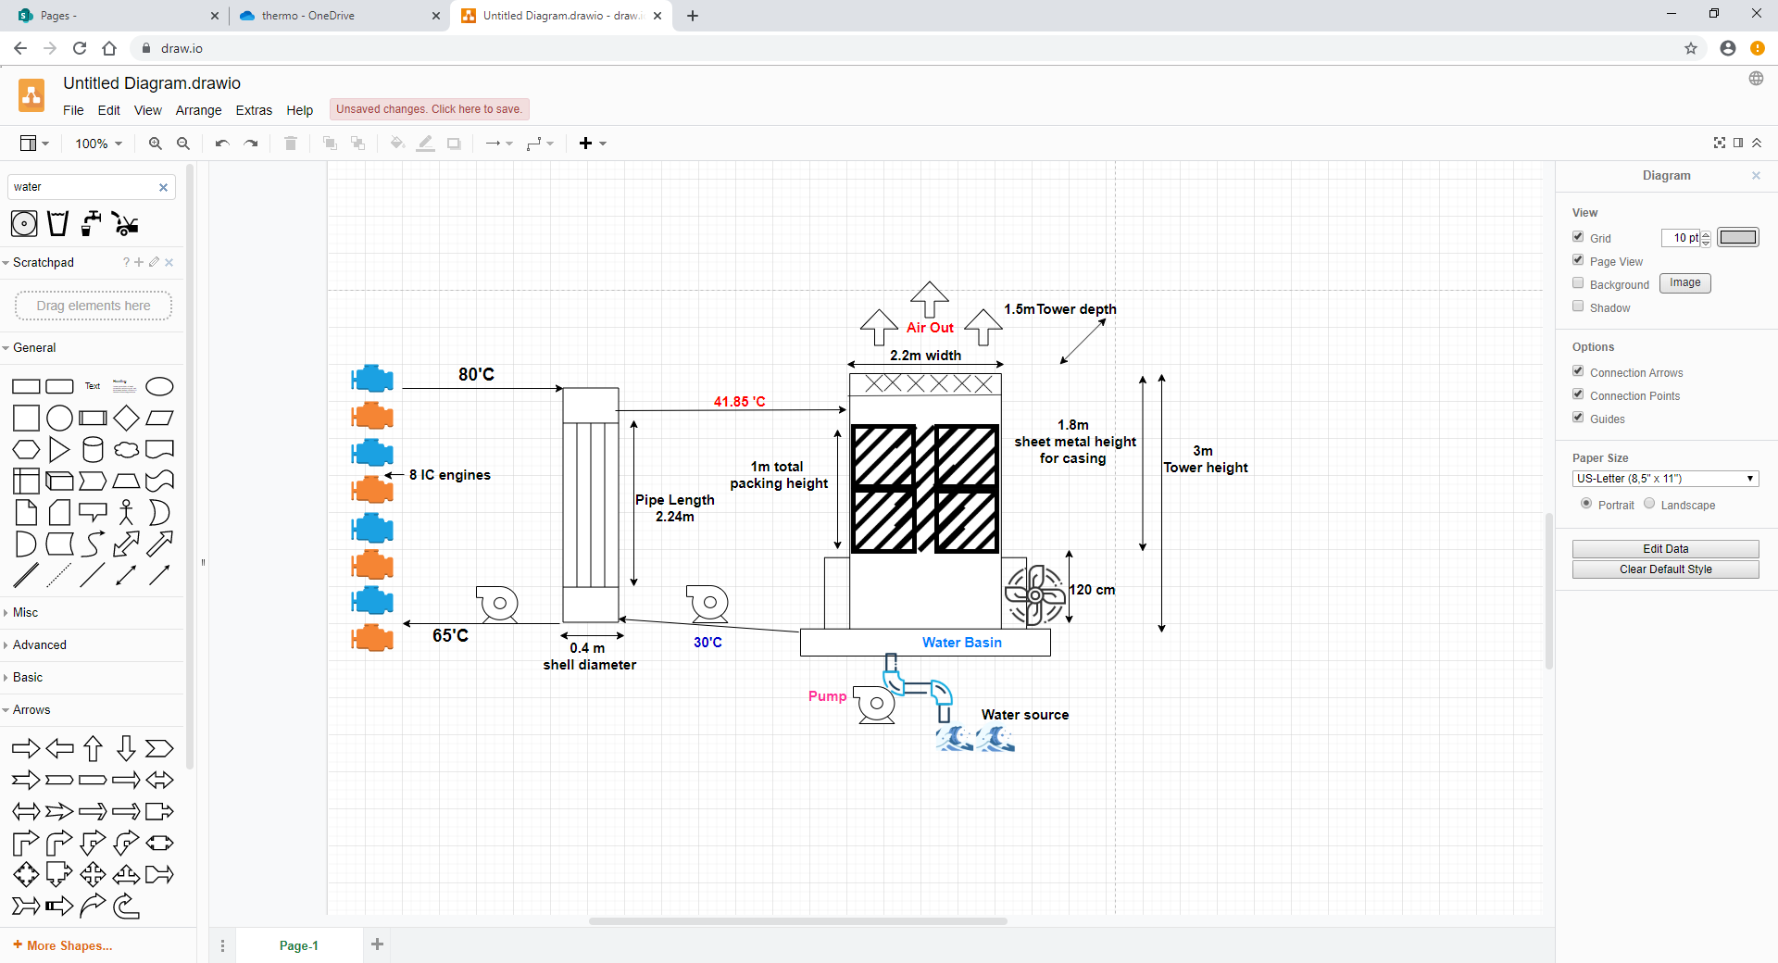

Discussion on Shell & Tube

Shell and tube 1 pass can withstand high pressures. In the heat exchanger tubes, where hot fluid passes through, the pressure is higher than the shell of the heat exchanger, therefore they can be made from different materials which can reduce the costs for the manufacturer. Shell and tube separate the mediums, therefore it’s easy to dismantle and clean it if required. They are also cheaper than plate heat exchangers (Edwards, 2008).

Discussion on Counter flow tower

Counter flow induced draft has been chosen, instead of the cross-flow system. This would mean that there will be less space occupied due to smaller height, this is because of the compact fill. Using less space leads to less material costs that would be used to make up the cooling tower’s casing, smaller eliminators, pipes required, and smaller water base.  
In the counter flow tower, the coldest water comes in direct contact with the dry air, which enhances the tower performance. And the key point to selecting this design over the other was that there will be more efficient contact between the water and air due to the more uniformly droplet distribution.

Assumptions

. Adiabatic process, thus no heat is lost to the surrounding, meaning the insulation was 100%. In reality insulation is required, and the process isn’t fully adiabatic, and some heat will escape.

. Ambient conditions don’t change, where as in real life, the weather is constantly changing, therefore the ambient conditions aren’t constant.

. The medium used is incompressible, which simplified the calculations, where as in real life, the water density does change with change in pressure, and hence its volume.

. The water in the pipes are assumed turbulent, but it could’ve been laminar at some sections or transitional in other cases. Also, the air flow is assumed uniform.

. Isobaric condition was assumed, so the change of temperature is constant. For example, the water that leaves the heat exchanger will be the same as the one entering in cooling tower, however, temperature will change for a small amount in real life.

. The water in this cooling tower is more uniformly distributed than cross flow. However, the distribution isn’t 100%.

. We have assumed no head loss, even though in the counter flow more head is loss than cross flow, specially with increase of height. Therefore, head loss had to be taken in consideration in real life.

Conclusion

The assumptions will therefore change the calculations a lot and will reduce the effectiveness of the cooling tower and the overall system. Also, this would mean the costs would be higher because of this. However, I do strongly believe that the system will work. The design meets the critical appraisal of the design, and we can see that water moving in from the cooling tower at 30’C is enough to reduce the engine’s water side to the desired 60’C. All the critical calculations have been made and they agree that this design is capable of being made. I do believe that the water outlet from tower can also be reduced far more than 30’C in reality, if the right improvements are made.

References

alibaba, a. (2019). *Shell And Tube Heat Exchanger - Buy Shell And Tube Heat Exchanger,Tube Heat Exchanger,Heat Exchanger Product on Alibaba.com*. [online] www.alibaba.com. Available at: https://www.alibaba.com/product-detail/Shell-and-tube-heat-exchanger_62083672852.html?spm=a2700.7724838.2017115.25.541c7eaesN8Zer&s=p [Accessed 23 Nov. 2019].

Airflow.com. (2019). [online] Available at: https://www.airflow.com/AIR1/AIR1-SHOP2/PDF/Brochures/industrial-fans.pdf [Accessed 20 Nov. 2019].

Chiesa, L. (2019). *Tower Packing Information*. [online] Available at: https://www.globalspec.com/learnmore/manufacturing_process_equipment/heating_cooling_equipment/tower_packing [Accessed 19 Nov. 2019].

Edge, E. (2019). *Overall Heat Transfer Coefficient Table Charts and Equation | Engineers Edge | www.engineersedge.com*. [online] Engineersedge.com. Available at: https://www.engineersedge.com/thermodynamics/overall_heat_transfer-table.htm [Accessed 9 Nov. 2019].

Edwards, J. (2008). *Design and rating shell and tube*. [online] Available at: https://www.chemstations.com/content/documents/Technical_Articles/shell.pdf [Accessed 1 Nov. 2019].

Jassim, D. (2016). [online] Pmu.edu.sa. Available at: https://www.pmu.edu.sa/attachments/academics/pdf/udp/coe/dept/me/cp/design-construction-pilot-scale-cooling-tower.pdf [Accessed 12 Nov. 2019].

LTD, M. (2019). *Galvanised Tube | Mild Steel | metals4U*. [online] Metals4u.co.uk. Available at: https://www.metals4u.co.uk/mild-steel/c6/galvanised/c1636/tube/c1638 [Accessed 20 Nov. 2019].

Rao, S. (2019). [online] Pdfs.semanticscholar.org. Available at: https://pdfs.semanticscholar.org/b57e/1d4726cc73b82c5dc5ea782f6c32be949655.pdf [Accessed 7 Nov. 2019].

Subramanian, S. (2019). *Shell-and-Tube Heat Exchanger Design*. [online] Web2.clarkson.edu. Available at: https://web2.clarkson.edu/projects/subramanian/ch330/notes/Shell%20and%20Tube%20Heat%20Exchanger%20Design.pdf [Accessed 3 Nov. 2019].

Homepage. (2019). *VFH-20 Vertical offset film fill*. [online] Available at: https://www.hewitech.de/en/product/detail/vfh-20-vertical-offset-film-fill/ [Accessed 20 Nov. 2019].